Lecture 2.1.3
Recurrence Relations with constant coefficients

Course outcome to be covered:
CO1: Apply and recognized about the Recurrence Relations with constant coefficients

Recurrence Relations:
A recurrence relation for a sequence 𝑎₀, 𝑎₁, 𝑎₂, … ({a_{n}}) is a formula that relates each term ak to certain of its predecessors 𝑎_{k-1}, 𝑎_{k-2}, … , a_{k-i} (one or more of the previous terms of the sequence), where i is an integer with 𝑘_{i} ≥ 0.
In other words, a recurrence relation is like a recursively defined sequence, but without specifying any initial values (initial conditions). Therefore, the same recurrence relation can have (and usually has) multiple solutions. If both the initial conditions and the recurrence relation are specified, then the sequence is uniquely determined.
Example:
Consider the recurrence relation a_{n} = 2a_{n-1} – a_{n-2} for n = 2, 3, 4, … Is the sequence {a_{n}} with a_{n}= 3n a solution of this recurrence relation?
For n ≥ 2 we see that 2a_{n-1} – a_{n-2} = 2(3(n – 1)) – 3(n – 2) = 3n = a_{n}. Therefore, {a_{n}} with a_{n}= 3n is a solution of the recurrence relation
Fibonacci Numbers:
Consider the recurrence relation 𝐹_{k} = 𝐹_{k-1} + 𝐹_{k-2} for all integers 𝑘 ≥ 2
Initial conditions 𝐹₀ = 1, 𝐹₁ = 1.
Compute 𝐹₂, 𝐹₃ and so forth through 𝐹_{7.}
- 𝐹2 = 𝐹1+ 𝐹0= 1 + 1 = 2
- 𝐹3 = 𝐹2+ 𝐹1 = 2 + 1 = 3
- 𝐹4 = 𝐹3+ 𝐹2= 3 + 2 = 5
- 𝐹5 = 𝐹4+𝐹3= 5 + 3 = 8
- 𝐹6 = 𝐹5+ 𝐹4= 8 + 5 = 13
- 𝐹7 = 𝐹6+ 𝐹5= 13 + 8 = 21
Examples:
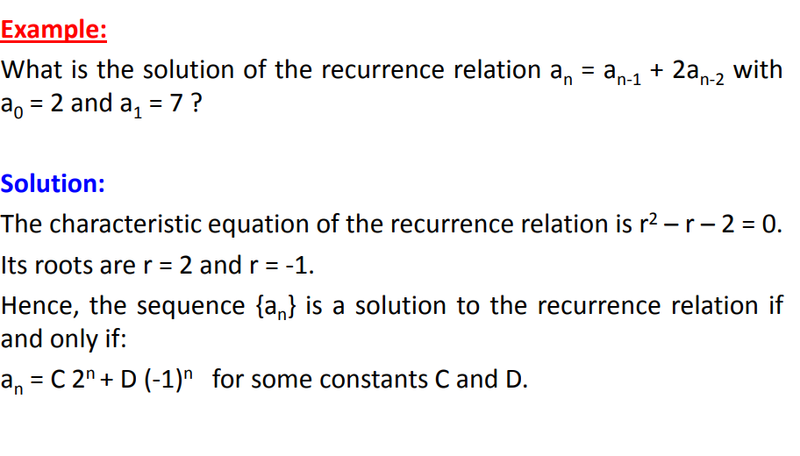
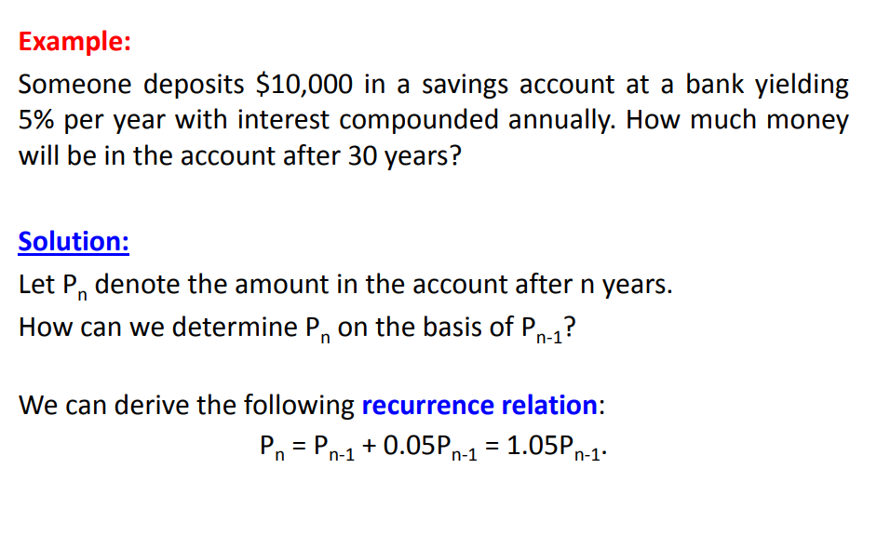
Order of recurrence relation:
The order of recurrence relation is the difference between the highest and the lowest subscript of S(K).
For e.g. The Fibonacci sequence is defined by the relation. FK = FK-2 + FK-1, K ≥ 2, F0 = 1, F1 =1
Here the difference between the highest and the lowest subscript of F = K - ( K - 2 ) = 2
Therefore its order is 2.
Degree of recurrence relation:
It is the highest power of S (K) occurring in recurrence relation.
For e.g. consider the example S4 (K) + 3S3 (K-1) + 4S2 (K-2) + 4S(K-3) = 0. Here degree = 4 (the highest power).
Linear recurrence relation:
A recurrence relation with degree one is called linear recurrence relation.
Linear Recurrence Relations with Constant Coefficients:
A Recurrence Relations is called linear if its degree is one. The general form of linear recurrence relation with constant coefficient is
C₀ y_{n+r}+C₁ y_{n+r-1}+C₂y_{n+r-2}+⋯+C_{r} y_{n}=R (n)
Where C₀,C₁,C₂......C_{n} are constant and R(n) is same function of independent variable n. A solution of a recurrence relation in any function which satisfies the given equation.

Linear Homogeneous Recurrence Relations with Constant Coefficients:
The equation is said to be linear homogeneous difference equation if and only if R (n) = 0 and it will be of order n.
The equation is said to be linear non-homogeneous difference equation if R (n) ≠ 0.
Example: Solve the difference equation a_{r-3ar-1+2ar-2=0.}
Solution: The characteristics equation is given by
s²-3s+2=0 or (s-1)(s-2)=0
⇒ s = 1, 2
Therefore, the homogeneous solution of the equation is given by
a_{r}=C¹_{r}+C².2^{r}.

eBook Discrete Mathematics :
https://www.math.uvic.ca/faculty/gmacgill/guide/recurrences.pdf
video link:
https://www.youtube.com/watch?v=eAaP4XaB8hM

